

System Configuration Software
for the


Mobile Device Charging Station

Product | Charge Daddy System Configuration Guide
Version | 1.d

Technical Instruction Guide

November 2013

Document Revision History

Tiburon Lockers, Inc.
Title: | Administrative User Guide for the Charge Daddy System Configuration Software
Date | Revision | Author | Description
04/26/2013 | 1.a | NDP | Pre-Release of Documentation
05/31/2013 | 1.b | NDP | Updated device name
08/20/2013 | 1.c | NDP | Updates to process and images
11/19/2013 | 1.d | NDP | Corrections to Grammer

Table of Contents

1. Introduction 4
2. Assumptions and Prerequisites 4
3. Using the Charge Daddy Configuration Software 4
3.1. Accessing the Configuration Software 4
3.2. Configuring the System 5
3.2.1. Abandoned Devices 5
3.2.2. Access Codes 5
3.2.3. Advertising 6
3.2.4. Application Commands 6
3.2.5. Authorize.NET Settings 6
3.2.6. Auto Restart 7
3.2.7. Backup/Restore 7
3.2.8. Compartment Type 7
3.2.9. Compartments 7
3.2.10. Credential Type 8
3.2.11. General Settings 8
3.2.12. Grace Period 9
3.2.13. Hardware 9
3.2.14. Screen Saver 9
3.2.15. User Accounts 9
3.2.16. User Roles 9
3.2.17. Verifone Settings 10

Introduction
This document provides an overview of the Tiburon Charge Daddy System Configuration Software.

Assumptions and Prerequisites
- Administrator has been properly trained on all the Charge Daddy capabilities and on how to correctly setup and operate them.
- Charge Daddy Software has been installed onto PC of Charge Daddy system.

Using the Charge Daddy Configuration Software

Accessing the Configuration Software
Follow the steps below to access the Configuration Software.
- Touch default screen, system will go to the rental options page.
- Enter the Tiburon Screen Corner Code.
- Before entering the Administrator Code, touch top left corner and slide finger across to top right corner. If done correctly, text in red bar will change as shown in Figure 2 below.
- On keypad enter the assigned Admin Code and select Enter.
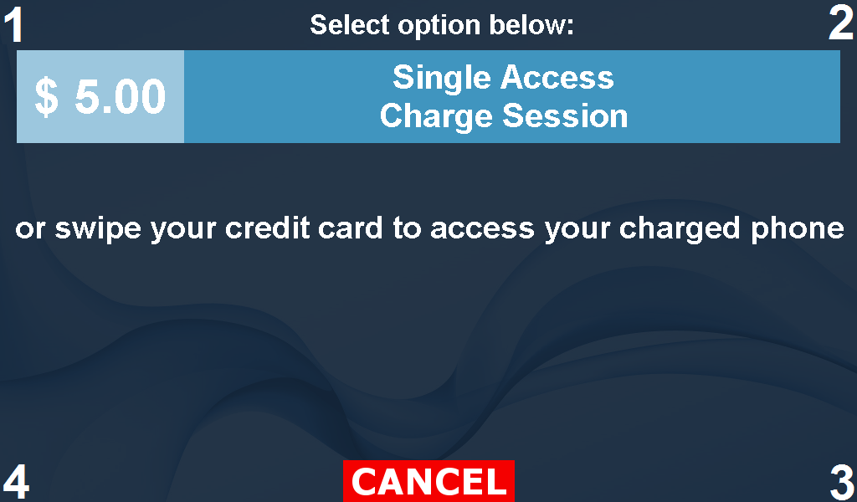

Figure 1: Administrative Access
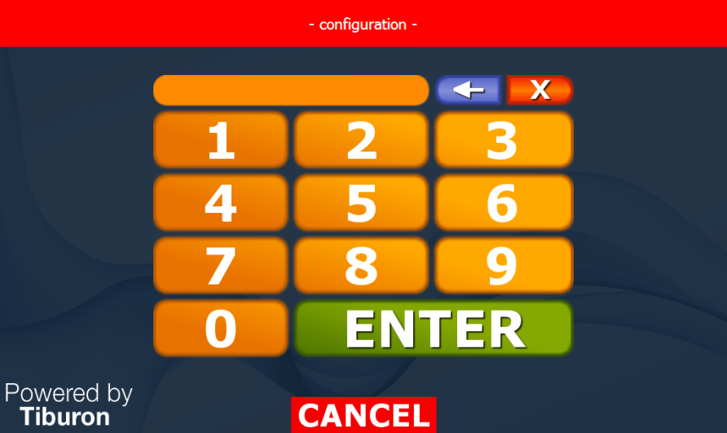

Figure 2: Tiburon Administrative Access
Once the login is successful, the user will be connected to that systems configuration software. This
section allows the Administrator to setup the overall system, and is designed to manage, control and
monitor the overall activities of the Charge Daddy System.
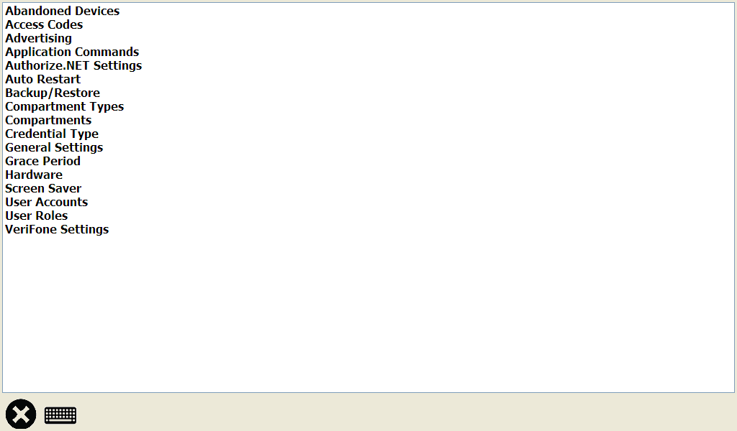

Figure 3: Charge Daddy Configuration Software

Configuring the System

The Charge Daddy Configuration Software is structured into various modules that are in the form of a list, simply tap the item you wish to view. A brief description and usage method for each of these modules is explained in the following sections.

- Abandoned Devices
- Access Codes
- Advertising
- Application Commands
- Authorize.NET Settings
- Auto Restart
- Backup/Restore
- Compartment Types
- Compartments
- Credential Type
- General Settings
- Grace Period
- Hardware
- Screen Saver
- User Accounts
- User Roles
- Verifone Settings

Abandoned Devices
The Abandoned Device page is broken out into 4 sections: General, E-Mail, Notifications, and Timeout. In this section an Administrator can enable the system to flag contents of a compartment as abandoned if device has not been removed as of the time specified. The timeout can be set in seconds, minutes or hours, and is the amount of time after rental has ended the system will wait before flagging a device as abandoned. An Administrator can choose to send a notification to a specified addresses by adding the address to the notification list. In order for the system to send an email, the server information will need to also be saved to the system.

Access Codes
The Access Codes page is where the list of all the defined Access Codes saved in the system can be found. Access Codes would apply when the systems credential type and/or payment type is set to ‘Code’.

Adding a New Access Code
To add a new access code, select ‘Add’. Fill in the code and select OK.

Editing Current Access Code
To edit an access code, select code from list and select ‘Edit’. Fill in the new code and select OK.

Deleting Current Access Code
To delete an access code, select code from list and select ‘Delete’. System will ask you to confirm before deleting.

Importing list of Access Codes
You can add multiple access codes to the system at the same time by selecting ‘Import’. Select file and open, codes will fill into table.

Advertising
The Advertising page is where an Administrator can activate the use of advertisements saved to the system, set how long an ad will display for as well as if end user has the ability to skip the advertisement.

Application Commands
The Application Commands page is broken out into 2 sections: Application and System. This page is where an Administrator can select application commands to perform.

Application
The Application commands allow an Administrator the ability to shut down or restart the Charge Daddy software.

System
The System commands allow an Administrator the ability to shut down or restart the Charge Daddy pc.

Authorize.NET Settings
The Authorize.NET Settings page is broken out into three sections: General, Credentials and URL’s. This page is where an Administrator would add the appropriate information to be able to process credit card transactions through a venues processing solution. The venue will need to establish a Authorize.Net account in order to use.

General
This section is where an Administrator can enable the use of an Authorize.NET account. The Administrator will also need to set the Pre-auth amount here too.

Credentials
This section is where an Administrator will enter the Authorize.NET account information. ie: Login, Transaction Key, etc.

URL’s
This section is where an Administrator will enter the AIM (Advanced Integration Method) and CP (Card Present) information.

Auto Restart
The Auto Restart page is where an Administrator can set the system to automatically restart the Charge Daddy software or the PC at specified time increments. Restart time and Idle time can be set in seconds, minutes, hours or days.

Backup/Restore
The Backup/Restore page is where an Administrator can perform a backup of the database or restore an existing database.

Compartment Type
The Compartment Types page is where a list of all defined compartment types that are saved in the system can be found (mobile phone, tablet, etc.).

Adding a Compartment Type
To add a new compartment type, select ‘Add’. Fill in the compartment name, choose type integer and select OK. Please note that the integer for the type should be in numeric order and should never be used for more than one compartment type.

Editing Current Compartment Type
To edit a compartment type, choose type from list and select ‘Edit’. Modify the compartment name and/or type and select OK.

Deleting Current Compartment Type
To delete a compartment type, choose compartment type from list and select ‘Delete’. System will ask you to confirm before deleting.

Compartments
The Compartments page is where all the defined compartments saved in the system can be found.

Adding a New Compartment
To add a new compartment, select ‘Add’. Select the compartment type, fill in the address control board is set to and select OK.

Adding Multiple Compartments
To add multiple compartments, select ‘Add Many’. Select the compartment type, fill in the start address, number of compartments and select OK.

Editing Current Compartment
To edit a compartment, select compartment from list and select ‘Edit’. Modify the compartment name and/or address and select OK.

Deleting Current Compartment
To delete a compartment, select compartment from list and select ‘Delete’. System will ask you to confirm before deleting.

Activating/Deactivating Selected Compartment
To activate or deactivate a compartment select the ‘Toggle Active’ button, box will be true if check mark is present.

Changing the status of a Compartment to Free
To free up a rented compartment that is known a customer is done with, select compartment (touch to highlight) and select ‘Free’.

Credential Type
The Credential Type page is where the lists of the defined credential types saved to the system can be found.

Adding a New Credential Type
To add a new credential type, select ‘Add’. Fill in the name, select type and select OK.

Editing Current Credential Type
To edit a credential type, choose type from list and select ‘Edit’. Modify name and/or type and select OK.

Deleting Current Credential Type
To delete a credential type, choose type from list and select ‘Delete’. System will ask you to confirm before deleting.

General Settings
This General Settings page is broken out into 6 sections: Miscellaneous, Timeout, Usage, Enable Upgrade, Admin Unlock, and Business Hours. An Administrator will set the unique parameters for the specified venue.

Miscellaneous
This section is where an Administrator will set the Credential Type and Payment Type. The Request Feedback option is also set here.

Usage
This section is where an Administrator will set the rental options and pricing the system should have. i.e: Single Use or VIP All Day. An Administrator also would set the Mode here. i.e: Business Hours or Price Per Time Unit.

Enable Upgrade
This section is where an Administrator can activate the ‘Upgrade’ option. If active single use user will get the option to upgrade their rental.

Unlock Steps
This section is where an Administrator will set the unique Tiburon screen corner code. Selecting the ‘Show’ button will bring up a separate window with the steps to take to use access code.

Business Hours
This section is where an Administator would set the start and end of the venues business hours.

Save Settings to Database
The Save button should be used if any changes are made. New settings will not be saved automatically.

Grace Period
The Grace Period page is where an Administrator can set and activate the systems grace period. This section is also where late fees are added and saved for each rental option.

Hardware
The Hardware page is broken out into five sections: General, Buffer, Flow Control, Timout, and Events. All the information shown on the Hardware page is related to the assigned COM port for each device connected to the system. All data on this page will be set by default. Administrative personal should never modify these details or the result will be the overall system not functioning properly.

Setting COM Port
To set COM port, navigate to the Windows Device Manager, select Ports and double tap device. The properties page for that device will open; next select Port Settings, Advanced, select the COM port from the drop down for ‘COM Port Number’ and select OK. System will set device to the specified COM port.

Screen Saver
The Screen Saver page is broken out into two sections: General and Miscellaneous.

General
This section is where an Administrator would enable the use or a screen saver and the timers related to it.

Miscellaneous
This section is where an Administrator would choose to use the screen saver(s) as the systems main screen.

User Accounts
The User page is where the list of the defined users saved in the system can be found.

Adding a New User
To add a new user, select ‘Add’. Fill in the name of user, assign the role user should have and select OK.

Editing Current User
To edit a user, choose user from list and select ‘Edit’. Modify name and/or role and select OK.

Deleting Current User
To delete a user, choose user from list and select ‘Delete’. System will ask you to confirm before deleting.

User Roles
The User Roles page is where the list of the defined user roles saved in the system can be found.

Adding a New User Role
To add a new user role, select ‘Add’. Fill in the name of role, assign the rights the role should have and select OK.

Editing Current User Role
To edit a user role, choose role from list and select ‘Edit’. Modify name and/or rights and select OK.

Deleting Current User Role
To delete a user role, choose role from list and select ‘Delete’. System will ask you to confirm before deleting.

Verifone Settings
The Verifone Settings page is broken out into three sections: General, Credential, and Connection. An Administrator would fill in the appropriate information needed to process credit card transactions with Tiburon account.

General
This section is where an Administrator can enable the use of Tibiron’s Verifone account. The Administrator will also need to set the Pre-auth amount here too.

Credentials
This section is where an Administrator will enter the Verifone account information. ie: Client ID, User ID, Password, etc.

Connection
This section is where an Administrator will enter the Verifone connection information. ie: Server, Port, etc.

Note: This document is for Tiburon personnel only; distribution of this document is strictly prohibited.

